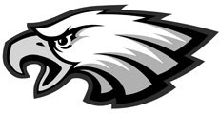

Eagles Baseball Club
PO Box #56443, Virginia Beach, VA 23456
A Non-Profit Organization Supporting Landstown High School Baseball

Baseball Banners Program

EAGLES BASEBALL CLUB MISSION:
The Eagles Baseball Club is a non-profit organization established in 2006, formed to aid and sustain community spirit in baseball and associated activities for the Landstown High School Baseball program. Due to the restricted budgets of the school system our organization has stepped forward to take on fundraising for the Landstown High School baseball organization. Our fundraising efforts provide supplies for the maintenance of the ball field, baseball equipment, field maintenance equipment, uniforms, funding for summer and fall baseball programs and provides funding for team development activities. Please consider making a tax deductible donation to support our activities. Our EIN Number is 14-1971056.

OUR REQUEST:
We are asking for your business sponsorship to support Landstown High School Baseball program by being part of our Banner Program. A banner with your company information will be proudly displayed on the fence line of Landstown Eagles’ baseball field. The sponsorship is for a one-year period and your banner will be displayed during the active playing seasons and stored in the off season. The levels of sponsorship are detailed on page two.

DONATION RECOGNITION:
In addition to your banner being displayed, your business will be announced at our games and other fundraiser events, and your business name and logo will be featured on our website (http://www.landstownbaseball.com) for the period of sponsorship.

Thank you for your consideration.

Angela Morales
President, Eagles Baseball Club
757-309-2538
eaglesbaseballclub@aol.com

EAGLES BASEBALL CLUB
BASEBALL BANNER PROGRAM SPONSORSHIP LEVELS

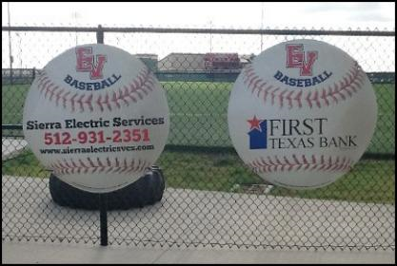

The image above is an example of the sponsorship banner
Grand Slam: 2.5 foot diameter, $1000
- Includes company name, phone number, and website or email address

Homerun: 2 foot diameter, $500
- Includes company name, and phone number or website or email address

Walk-off: 1.5 foot diameter, $300
- Includes company name, and phone number or website or email address

Loud Fan: Website Sponsor only, $100

Renewal? We’ll store your banner in the off-season, so subtract $150 from the Banner prices above. For Loud Fan website sponsors, please consider displaying a banner or renew your website sponsorship for $75.

Make checks payable to EAGLES BASEBALL CLUB

Sponsors, please provide:
- Business name and address
- Business website
- Contact name
- Contact number
- Contact email address
- And… what level sponsorship you desire

